HUNGARY – LAND OF HEALING WATERS

A tiny territory in the middle of Europe, Hungary is little thought of as a holiday destination but has more than enough to recommend it to anyone.
The capital Budapest is without a doubt what the country is most famous for. It is an intensely beautiful city, full of baroque architecture, and an Empire's worth of art works and treasure. The twin cities (Buda and Pest) together make up a conurbation of two million inhabitants,
with Buda being the older, more historic part of the city and Pest the lively modern quarter.

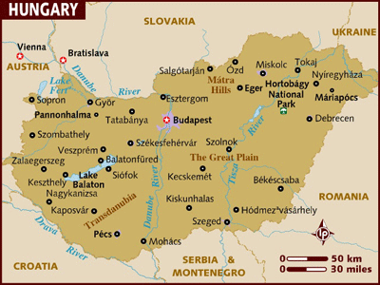

LOCATION :
Landlocked Hungary is bounded by Austria, Slovakia, the Ukraine, Romania, Yugoslavia, Croatia and Slovenia.
After Iceland it has the world's second largest reserves of surface thermal water and Lake Balaton is Central Europe's largest lake. Nearby Heviz has the second largest warm water lake in the world (Lake Gyogy - with an average surface temperature of 30°C).
The Danube, Europe's second longest river (behind the Volga) flows through the heart of the nation. Budapest is its capital.

VISA The visa is to be obtained prior to arrival in the country

HOW TO GET THERE :
International Airport:
Hungary's international airport is Budapest Ferihegy Airport located 24 kms. From the Capital.

Quite a few European Airlines fly to Budapest via their home country. Austrian Airlines has good connections as the flying time is around 10 hrs. compared to other airlines where the flying time is around 12/13 hours.

GETTING AROUND :

Air : Most international flights arrive at Terminal B. Terminal A is used almost exclusively by the national carrier Malev. There are no domestic flights within Hungary but regularly scheduled flights leave from Ferihegy for international destinations all around the world, including to Hungary's close neighbours.
To travel onwards internally from Budapest airport you should transfer into Budapest city centre and change to the train or bus. The cheapest way into the middle of town is local bus 93 to Kobanya-Kispest metro station thence to Deak Ter (about 35 minutes altogether).

Train : Most international trains arrive and depart at Budapest's splendid Keleti Station. From Budapest nowhere in the country is further than three and a half hours away by train and the city operates as the hub of all cross-country routes. Of the other stations in the capital, Budapest Nyugati is for stations in eastern Hungary, while Deli Station connects to Lake Balaton and domestic destinations west of the capital.
Trains are reasonable in price and relatively efficient. All Express routes require you to reserve seats in advance of travel and carry surcharges to do so.

Ferry : MAHART hydrofoil from Vienna to Budapest via Bratislava(6 hrs). Popular during summers.

Bus : Volan is the national bus company and operates local buses and inter-city coaches across the entire country. Also worth considering is the "Budapest card" which not only gives you unlimited travel on public transport for two or three days but also gives free admission to 55 museums, reductions on sightseeing tours and folklore programmes. It is valid for an adult plus a child under 14.

DISTANCES :
The following table provides approximate driving distances between Hungarian cities. Kilometres in the lower left of the table, miles in the upper right.
City | Bud | Lak | Pec | Gyo | Ege | Tok | Deb | Sop
Budapest | • | 67 | 132 | 74 | 77 | 137 | 138 | 128
Lake Balatan | 108 | • | 69 | 125 | 144 | 204 | 207 | 118
Pecs | 211 | 14 | • | 189 | 209 | 268 | 224 | 170
Gyor | 119 | 201 | 304 | • | 151 | 24 | 216 | 54
Eger | 124 | 232 | 336 | 243 | • | 64 | 78 | 205
Tokaj | 220 | 328 | 432 | 339 | 103 | • | 51 | 265
Debrecen | 222 | 333 | 360 | 348 | 126 | 83 | • | 270
Sopron | 205 | 190 | 274 | 87 | 329 | 426 | 434 | •

CURRENCY:
The currency is Hungarian Forint (HUF) .
Hungarian Forint (HUF) = 100 fillers. Due to devaluation filler coins have been taken out of circulation and fillers only exist as the Bank of Hungary's lowest denomination of the Forint.
If visitors arrive via Vienna, a common gateway, it is often advisable to obtain Forints there. Better rates of exchange are usually available than those you'll find in Hungary itself.

BUISNESS :
Shops are generally open from 07h00-19h00 Mon-Fri and 07h00-14h00 Sat.
Large department stores open from 10h00-18h00 Mon-Wed and Fri, 10h00-20h00 Thursday and 09h00-13h00 Sat.

CLIMATE :
Hungary has a temperate, continental climate. The summer months from May through August are generally warm to hot with temperatures reaching a daily average of 22°C in July. These are the best (and most popular) months to visit the country. Early summer and late spring, from April through the beginning of June, are the wettest months to visit and you can expect heavy rain showers at this time of year.
Spring and autumn are short seasons when the weather can become unsettled and changeable. During the winter months, from November through February you can expect fog and snow. Temperatures often fall far below 0°C in January, which is the coldest month but this can be one of the best times to visit with snowfall enhancing the already beautiful landscape.

TIME :
Hungary is 4 hours and 30 minutes behind India. (Subtract one hour for DST from March to October)

ELECTRICITY :
Electricity is 230 volts.

DIALLING CODE :
International dialling code: | 36
Area codes: | Budapest: 1, Debrecen: 52, Miskolc: 46, Szeged: 62, Pécsvarad: 72, Gyor: 96
To make national calls outside of Budapest when within Hungary you have to dial 06, followed by the area code and the local number.

TIPS :
Tipping in Eastern Europe is becoming increasingly common. The service charge is not normally included in the hotel or restaurant bill. In general you should tip waiters, taxi drivers and hotels 10% of the total cost of the service, at your discretion.
Please note that it is customary to give the tip directly to the waiter rather than leaving the money on the table

LANGUAGE :
Hungarian is the official language.

INFORMATIVE WEBSITE :
www.hungary.com

CITIES :

BUDAPEST :
Traversed by the mighty Danube, the Capital city is the transport hub for the whole of this relatively small country, whether arriving by boat from Vienna or Bratislava, or by plane from abroad.
Nowhere in the country is more than three and a half hours away by train or car. Most visitors will arrive here, and the majority of those will remain in Budapest for the duration of their Hungarian visit.

Accomodation Options in Budapest :
The twin cities of Buda and Pest each offer something different to the traveller and, depending on which one you choose to stay in, you can gain two distinctly different experiences. Buda is the more refined of the two, while Pest can position you right at the pulse of the city.
Most of the larger hotels are clustered on the banks of the river - although the Danube isn't quite so blue as it flows through the city. This area can still be pleasanter than staying in the narrow inner city during the sticky heat of summer. The Pest bank is the more popular of the two, with international chains choosing to locate here.
A slightly more economical option is the Kings hotel located close to Vaci street and just a 10 minute stroll to the Danube and its attractions.
Also look out for the independently owned large hotels from the Communist era. These can be amusingly kitsch inside with a décor that dates from anything between the late 60s to early 80s. If you're seeking something a bit quieter in Buda you should choose a pension (panzió). These hotels in converted town houses and period buildings are often pleasant and represent good value. You'll also find that you don't miss out on much when it comes to service by choosing a pension over a hotel.
Make sure you book in advance to secure the best range of hotels in the city. Although it is possible to get rooms immediately in the city, they aren't always the best quality. If you choose this option you should always insist on seeing a room before agreeing to take it.
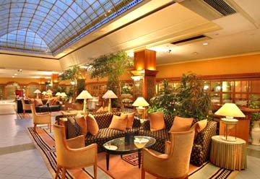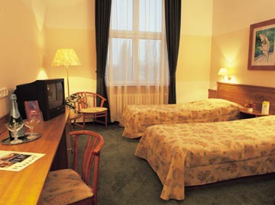

Must – Sees :
Parliament Building :
One of the largest state buildings in Europe, this neo-Gothic fantasy was completed in 1902 and remains one of Budapest's most dominant structures.
The magnificent façade facing the river stretches for a quarter of a kilometre, while the vast central dome that rises above serves as a landmark for locals and visitors alike. Since the downfall of Communism the building is once again serving its original purpose as the seat of Hungarian democracy but it's still possible to visit and explore this fascinating building. When parliament isn't sitting you can even visit the members' gallery benches.
The resplendent Hungarian crown jewels are also on show, under permanent ceremonial guard. Open: daily.
Admission: HUF2000.

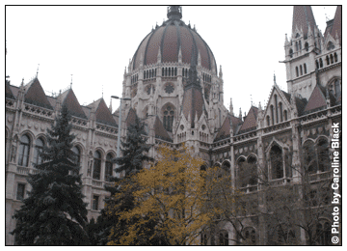

Castle District :
The Castle District is well worth a visit, providing visitors with fantastic panoramic views of the city and Parliament buildings. You can either take the Funicular train or walk the stairs to the top of the hill. One of the most striking sights are the series of ramparts facing the river, Fisherman’s Bastion, named after the traditional defenders of this stretch of the walls. In fact the Bastion bears testament to representative of the seven original Magyar tribes that established the nation.
In the heart of the Castle District is the Matthias Church, one of the city’s most popular tourist draws. An attractive church in a Romanesque style it is easily recognisable by its patterned roof and elaborate main spire. The cobbled streets in between the church and royal palace are lined with attractive medieval houses some of which are now craft shops and cafés.
Fisherman's Bastion admission: HUF300, adults; HUF150, children. Matthias Church admission: HUF600.
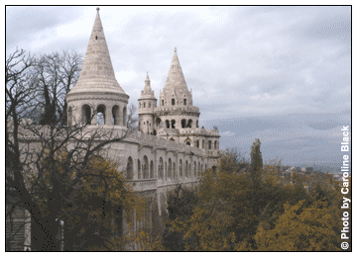

City Park :
Located at the end of the elegant Andrassy Boulevard is the City Park with its emblematic Heroes Square.
Facing the square from the west is the impressive Museum of Fine Arts and from the east is the Art Gallery. Once in the park there’s plenty to do and probably one of the best places in the city to take young children. The park offers a colourful play area, zoo and grand circus and plenty of parkland to amuse yourselves on one of the city’s warmer days.
It is also home to Szechenyi Spa baths and the attractive Sham castle, Vajdahunyadi, a copy of an original medieval dwelling in Romania.
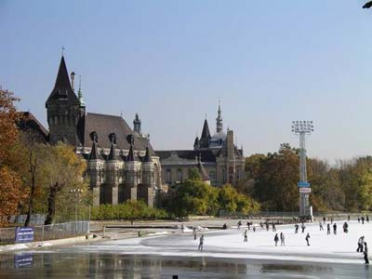

St. Stephens Church :
One of Budapest's most celebrated landmarks and the largest church in the country, St Stephen's took over 50 years to build, finally completed in 1906.
The views from the tower are among the most impressive in the city. It's well worth paying the extra and making the trip to the top if you visit. Hungarian Catholicism's most holy relic, the preserved right hand of St Stephen (the first Christian king of Hungary) can be found in the chapel. It's perhaps not the prettiest tourist attraction in the world but it's certainly among the most fascinatingly macabre.
Entry to the church is free although entry to the tower costs HUF500 per person.
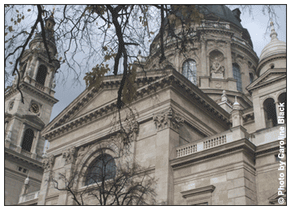

Margaret Island :
To enjoy a quiet stroll in beautiful surroundings head to the public park on Margaret Island.
The city hasn't encroached on this wooded enclave and it remains a focus of leisure time activity for the locals as much as visitors. Gardens, thermal pools and even an open-air theatre, in season, to ease your time away. Long and narrow, the island is connected to both Buda and Pest by bridges and is a peaceful refuge from Budapest's busy streets. About 2.5km long, there is one road on the island, and the only one open to a public bus meaning you can wander at your leisure, untroubled by traffic. The ruins of the 13th-century church and monastery that used to stand here are also well worth exploring. St Margaret herself is buried within the ruins - a marble plaque marks the spot. The bell tower of the monastery contains the oldest bell in Budapest - dating from the 15th century and still ringing
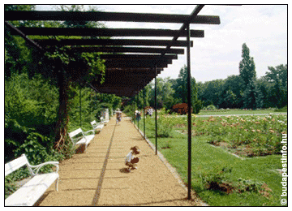

Gellert Hill :
Towering 750 feet above the Danube, Gellert Hill affords easily the best views of Budapest. It's a good idea to make this your first stop on arrival in the city as the major attractions can all be easily spotted, enabling the visitor to get a feel for the city away from the hectic maze of streets and people.
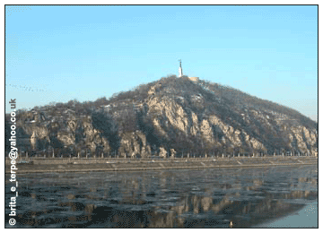

Thermal Baths :
An important Hungarian cultural institution, thermal baths remain popular today and there are several impressive bath houses to choose from in the city. The city's first baths were established in Roman times and then expanded under Turkish occupation. The neoclassical architecture of some of the older establishments is well worth seeing even if the idea of a thermal bath doesn't appeal.
The Szechenyi Spa Baths located in the city park is the place to watch chess enthusiasts who congregate around the stone boards and is one of the largest bathing complexes in Europe.
Open to men and women, 06h00-19h00 (May-Sept); 06h00-17h00 (Oct-Apr). Admission: HUF1300-2300.
The Gellért Spa Baths are one of the most popular baths probably due to its wealth of original Art Nouveau stained glass windows, mosaics and sculptures. Open to men and women, 06h00-19h00 (Mon-Fri); 06h00-17h00 (Sat-Sun, May-Sept). Admission: HUF3100.
The Kiraly is particularly atmospheric. Fo Utca 82-84. Open to men and women on alternate days. Admission: HUF1200
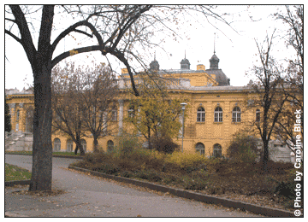

Ludwig Museum :
The Ludwig Museum is the only collection of contemporary art in the country holding an impressive array of national and international pieces, including several works by Picasso.
There is always lots going on at the Museum with events and exhibitions taking place throughout the year especially with its close ties to the Palace of Arts, the main music venue in the city. The museum also does a lot to encourage and promote local talent and even holds evenings where artists can talk about their current work and latest exhibitions.
Admission: free. This is a charge for temporary exhibitions
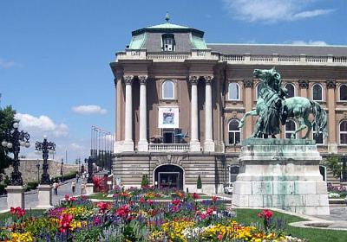
Holloko :
Holloko, in the Nograd Hills on the road to Slovakia is a UNESCO World Heritage village. This beautiful wooden settlement preserves the traditional architecture and peasant way of life of the region.
The experience takes you back centuries through Hungarian life. On Sundays the inhabitants even wear folk costume, just to give it that extra bit of authenticity. Although it's a great place to visit at any time, the magic of the place works better if you visit in the evening, after most of the tourist buses have departed. Alternatively, come out of season.
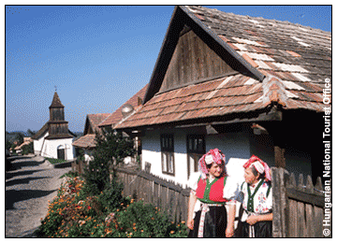
Pecs :
Hungary's fourth largest city and the seat of the country's oldest university (founded 1367) is in the Southern Mecsek Hills. Famous for almond trees, Zsolnay porcelain and Pannonia "champagne" Pecs is a lively town with plenty to see and do.
Central attractions include the Zsolnay Ceramics Exhibition in Kaptalan Ut, where almost every house is a museum, and the 16th-century Gazi Kassim Pasha Mosque (in Szechenyi Ter and now a Catholic church), the largest building remaining from the Turkish occupation of Hungary. The well preserved Little Mosque incorporates a museum of Turkish culture and the adjacent minaret affords excellent views over the city.
There's an antiques fair in the Market Square on the first Friday of the month, plus a huge flea market every weekend (in Nagyvasar). The town's upbeat nightlife is concentrated on pedestrianised Kiraly Utca off Szechenyi Ter. The train from Budapest Deli takes about two and a half hours.

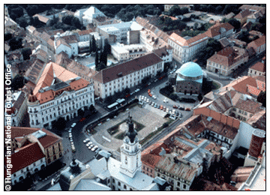

Lake Balaton :
Lake Balaton is a huge expanse of water, surrounded by various lakeside resorts offering a variety of entertainment.
The northern shore is characterised by long sandy beaches, perfect for summer sunseekers, whereas the shallower south-east shore becomes a centre for ice skating during the cold winter. One of the more popular destinations is Balatonfured, an elegant period spa. Nicknamed the "Mecca of cardiacs" Balatonfured has numerous natural springs and opportunities abound to bathe in, or "take" the mineral waters.
Unspoilt Tihany (whose northern peninsula is a national park) is particularly beautiful, with an interesting old Benedictine abbey, dating from 1754. Meanwhile Badacsony, on the fertile side of an extinct volcano, is the place for local wines while picturesque Szigliget is a charming old thatched village dominated by castle ruins.

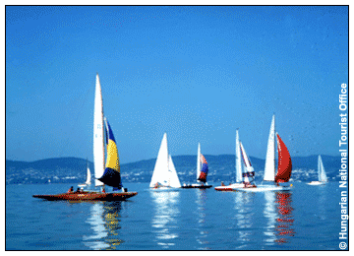

FOOD :

INDIAN RESTUARANTS:

Marquis de Salade  Hajos utca 43  Budapest 1065 Hungary  Tel: +36 1 302 4086 | Shalimar Indiai Etterem  Dob utca, 50  Budapest 1074 Hungary  Tel: +36 1 352 0305
Govinda  V. Vigyazo Ferenc ut 4  Budapest 1056 Hungary  Tel: +36 1 318 1144 | Maharaja Indian Restaurant  Becsi ut, 89-91  Budapest 1061 Hungary  Tel: +36 1 250 7544
Darshan Udvar  Krúdy Gyula  Budapest 1088 Hungary  Tel: +361 266 5541 | Bombay Place  VI. Andrássy út 44.  Budapest, Hungary  Tel: +331 1986

SHOPPING IN HUNGARY :
The antique shopping street, Falk Miksa utca, runs from Szt. Istvan Blvd. to Parliament. The shops offer the richest collection of antiques in Central Europe. In Budapest go to the Castle District to buy antiques at the small shops and on the streets "specializing" in folk art and antiques.

You can also find an enormous selection of wine from the historical Hungarian wine regions at the House of Hungarian Wines.
Polus Centre is the largest shopping center in Eastern Europe, on the size of 11soccer fields, movie theatres, shops. The Esceri flea market (in the XIX district, south of the city) is one of the best and biggest in Eastern Europe and sells everything from Soviet army watches to Fred Astaire top hats. Duna Plaza has over 200 shops within its vicinity. Europark is situated only few minutes from the city centre, in the heart of South-Budapest with its more than 63 shops and restaurants, services, entertainment programs. The Westend City Center (next to Western Railway Station) with 400 shops, a 14-screen cinema complex, entertainment center and a huge food-court, is changing the cityscape.
Budapest has an ample choice of things to do after dark - from opera, theatre, ballet and dance to rock, pop, jazz, and meat-market discos. Shops are usually open from 10 a.m. to 6 p.m. on weekdays, and from 9 a.m. to 1 p.m. on Saturdays. Shopping centers on weekdays are open till 8 p.m. and most of them are also open on Sundays.

